Jenkins Task-2

Task Description:
Create a simple script file and push it to repo. Create a project in Jenkins connected to your GitHub repository. When a commit is made to your repo, automatically build must get triggered from Jenkins and the output must be shared to me via email.

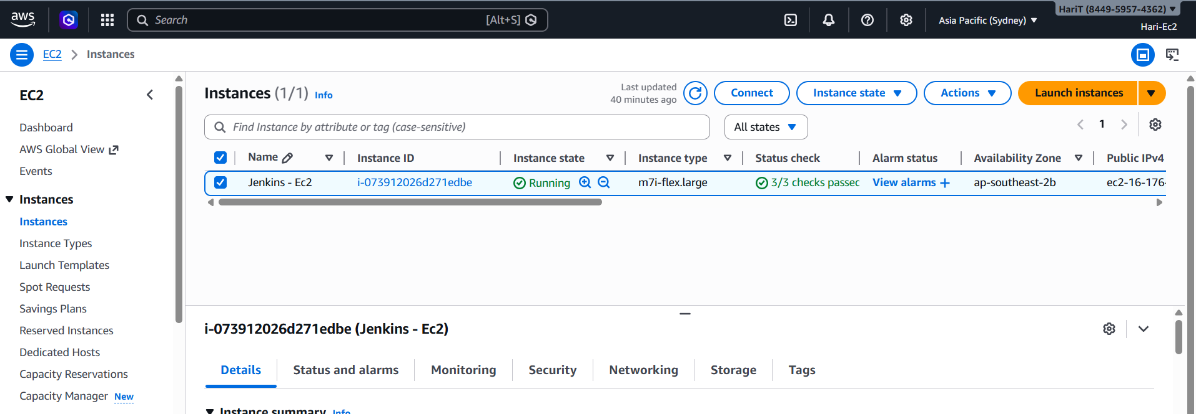

Connected git hub file to Jenkins
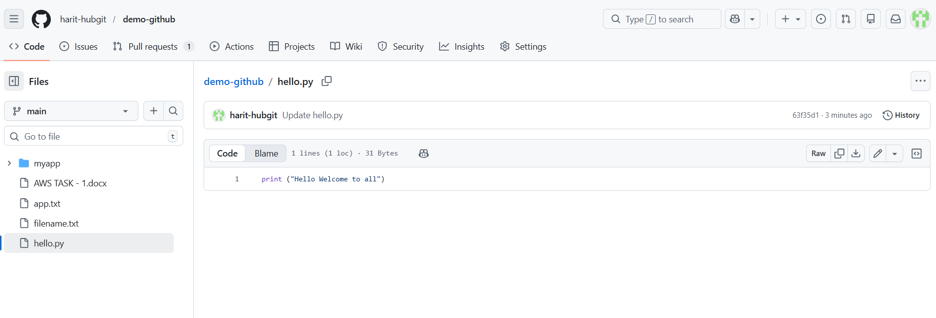
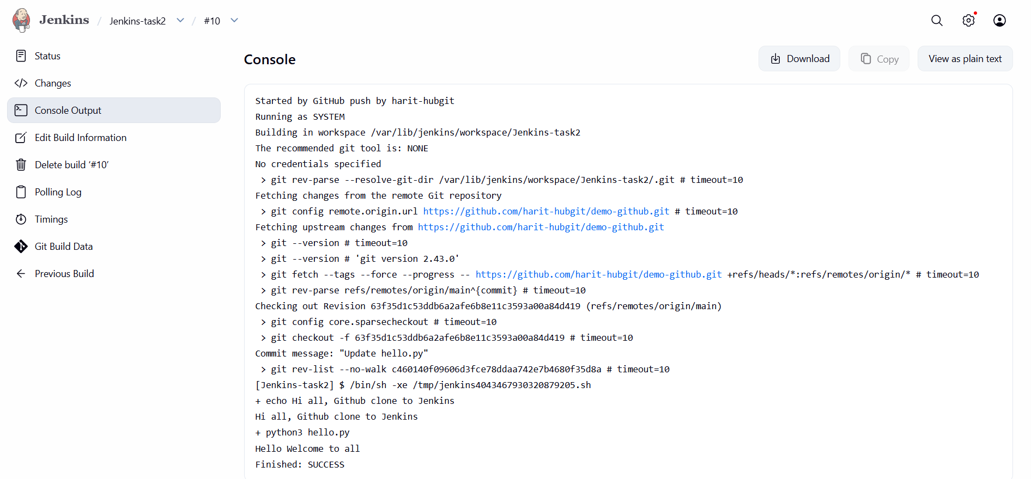
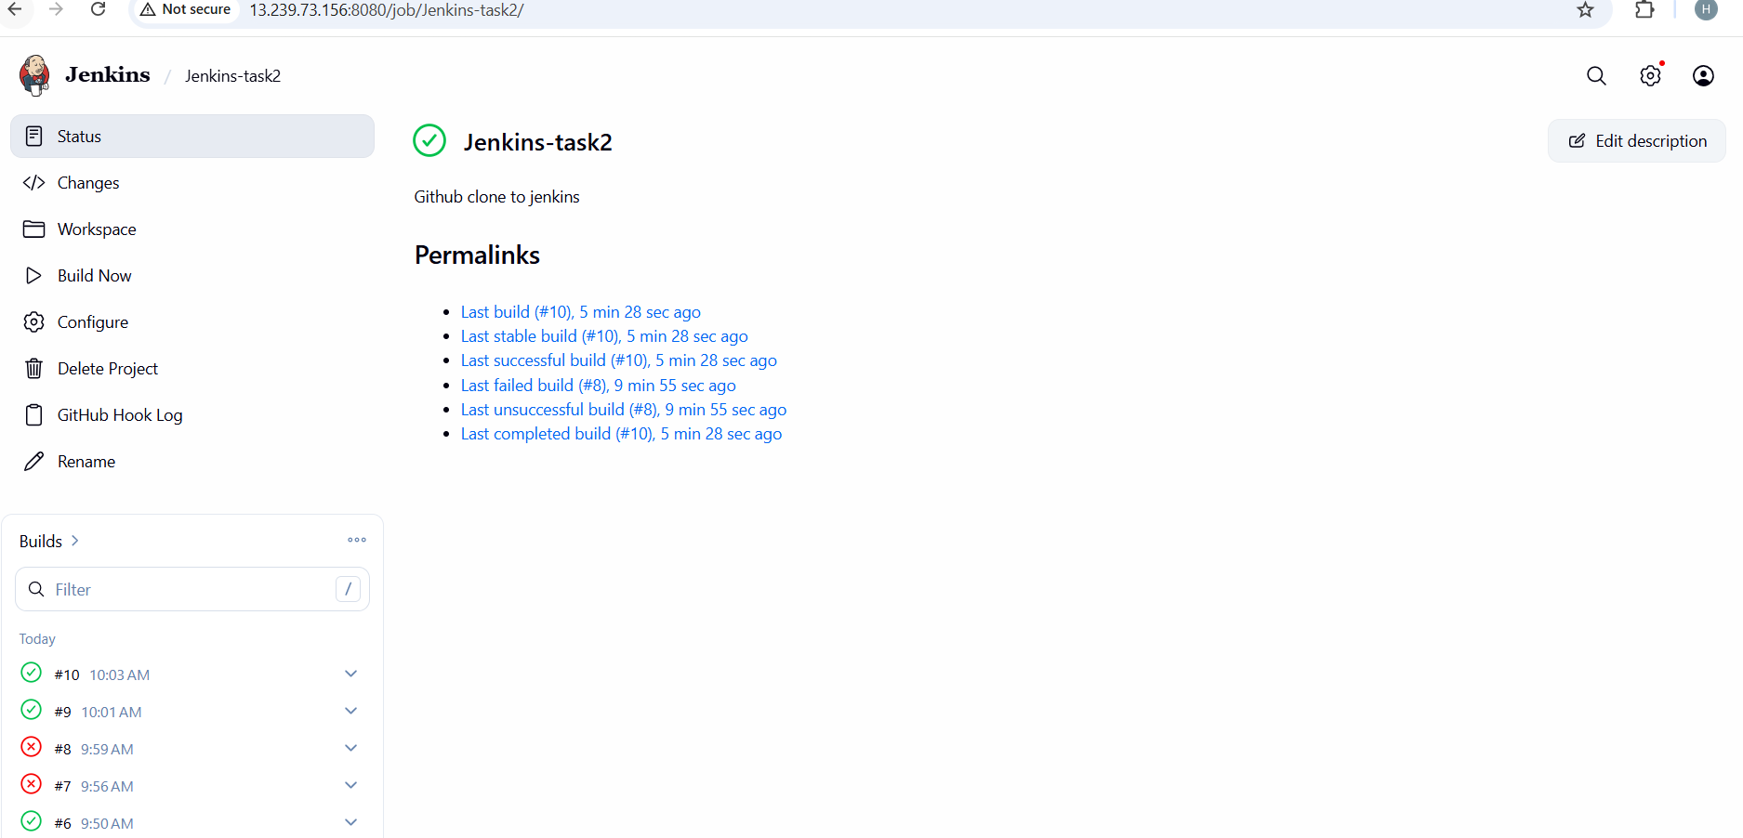

Now changes made in github hello.py file it reflects automatically in Jenkins
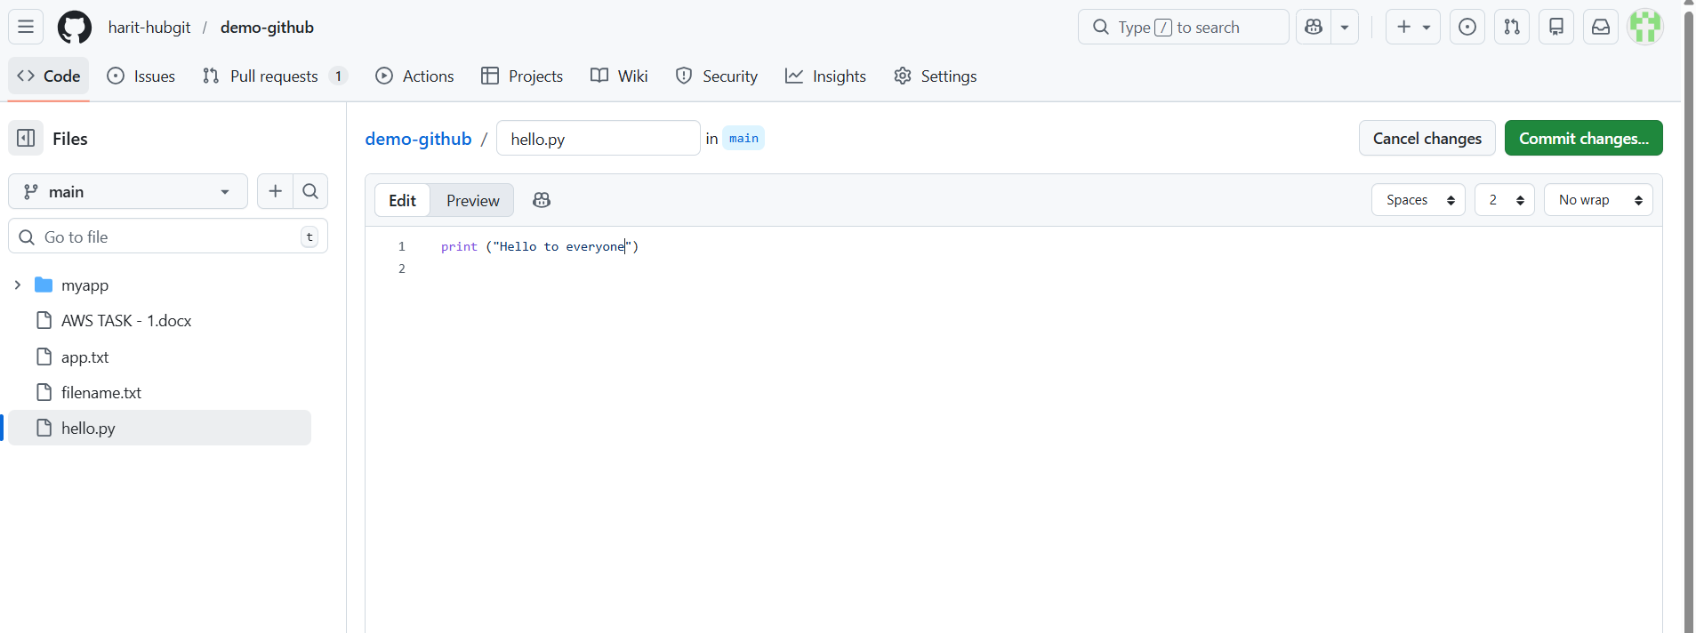
After commit done it will apply
